WEEK 3 REPORT
PwnTillDawn Online Battlefield
Target: 10.150.150.11 (PwnDrive)
Date: April 12, 2026

Executive Summary
Target IP | 10.150.150.11
Operating System | Windows (Apache/2.4.46 Win64, PHP/7.4.9)
Difficulty | Easy
Flag Retrieved | FLAG1 - PwnTillDawnAcademyIsAwesome!!!
Attack Vector | Improper Access Control + File Upload + Web Shell RCE
Privilege Level | NT AUTHORITY\SYSTEM (Highest Privilege)

Attack Phase Summary
Phase | Action | Outcome
Reconnaissance | Nmap scan | Identified open ports (80 HTTP, 21 FTP)
Enumeration | Directory browsing | Found /upload and /admin directories
Gaining Access | Create admin user via exposed panel | Full admin panel access
Exploitation | Web shell + command injection | Remote Code Execution (RCE)
Post-Exploitation | System enumeration via ?cmd= | Found Administrator Desktop
Flag Retrieval | Read FLAG1.txt | FLAG1 retrieved successfully

1. Reconnaissance (Information Gathering)
Objective: Identify the target attack surface and exposed services.
An Nmap scan was performed to identify open ports and running services on the target machine.
nmap -sV -Pn -T4 -p 21,80,443,3306,8080 10.150.150.11
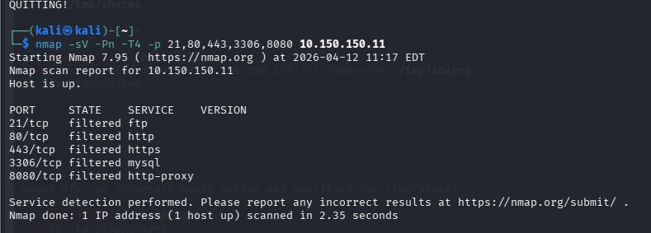
Figure 1 - Nmap scan results on 10.150.150.11

Service Table
Service | Port | Findings
FTP | 21 | Filtered - Anonymous login failed
HTTP | 80 | Open - PwnDrive web application running

2. Scanning & Enumeration
Objective: Extract deeper information from identified services.
The web application at http://10.150.150.11 was identified as PwnDrive, a personal cloud storage platform.
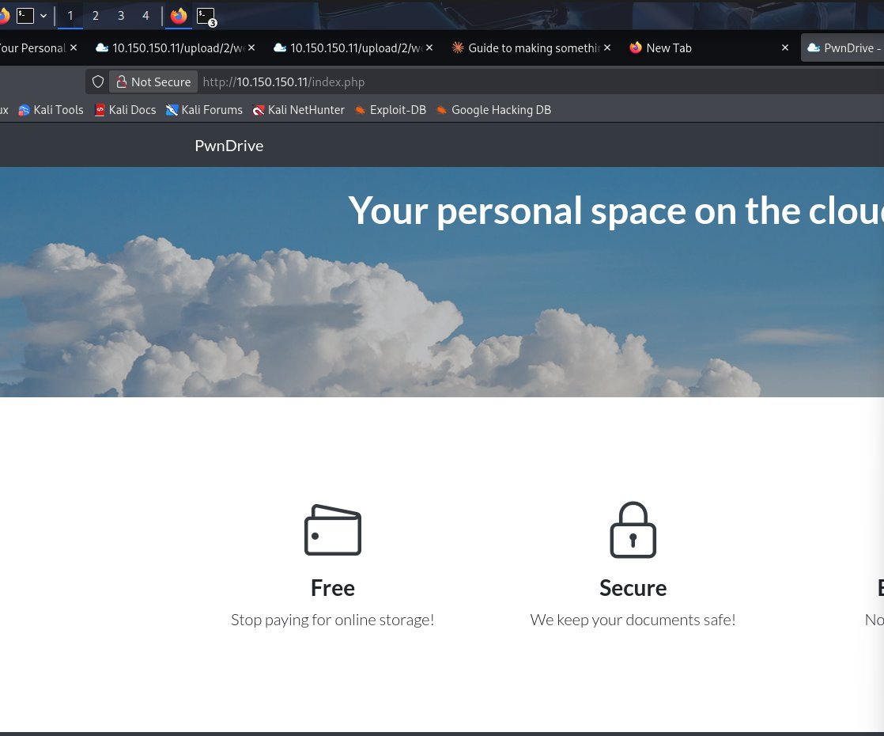
Figure 2 - PwnDrive web application running on port 80
Gobuster was used to discover hidden directories on the web server.
gobuster dir -u http://10.150.150.11 -w /usr/share/wordlists/dirb/common.txt

Discovered Directories
- /upload - Directory indexing enabled, files exposed publicly
- /admin - Admin panel accessible without authentication
- /admin/addedituser.php - User management page with no login required
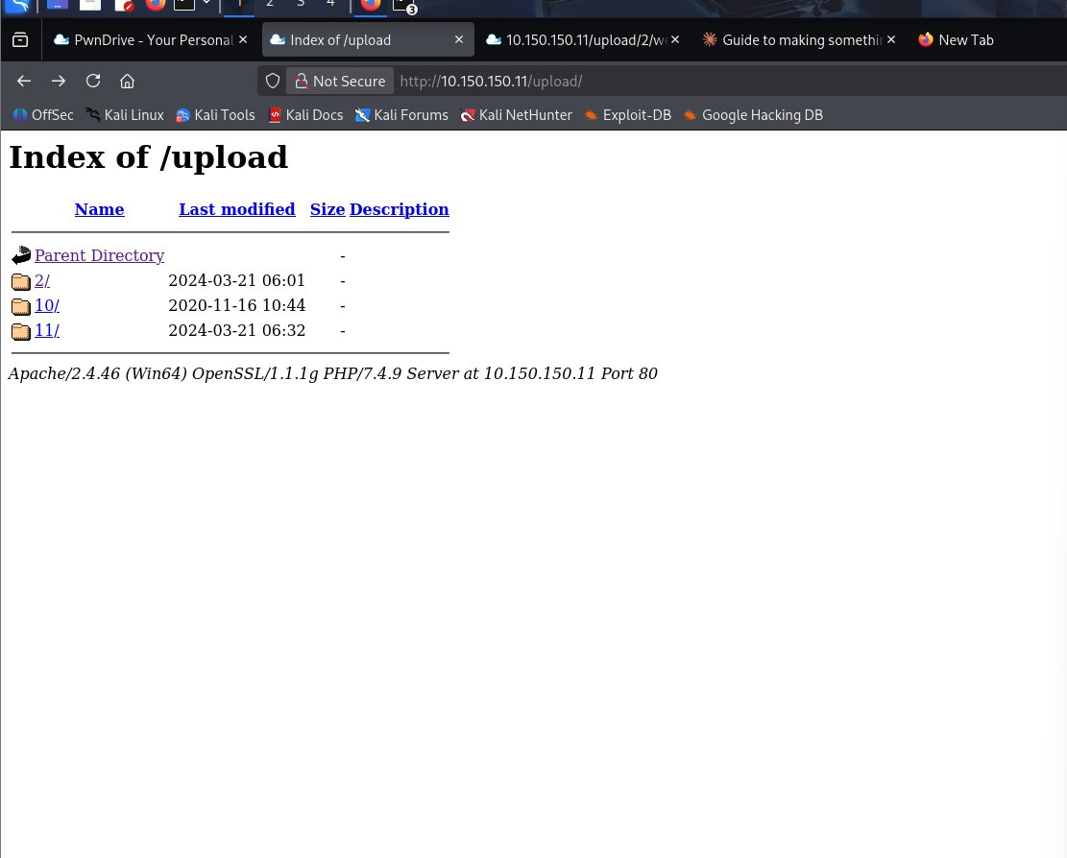
Figure 3 - /upload directory showing directory indexing enabled with webshell.php present

3. Gaining Access (Exploitation)
Objective: Exploit identified vulnerabilities to gain an initial foothold.

Vulnerability 1: Improper Access Control
The admin panel at /admin/addedituser.php was accessible without any authentication. A new admin user was created using this exposed functionality.
- Username: testuser
- Password: testuser
- Role: admin

Vulnerability 2: Unrestricted File Upload + Web Shell
A pre-existing PHP web shell was discovered in the /upload directory. The webshell accepted OS commands via the ?cmd= GET parameter, enabling Remote Code Execution.
http://10.150.150.11/upload/2/webshell.php?cmd=whoami
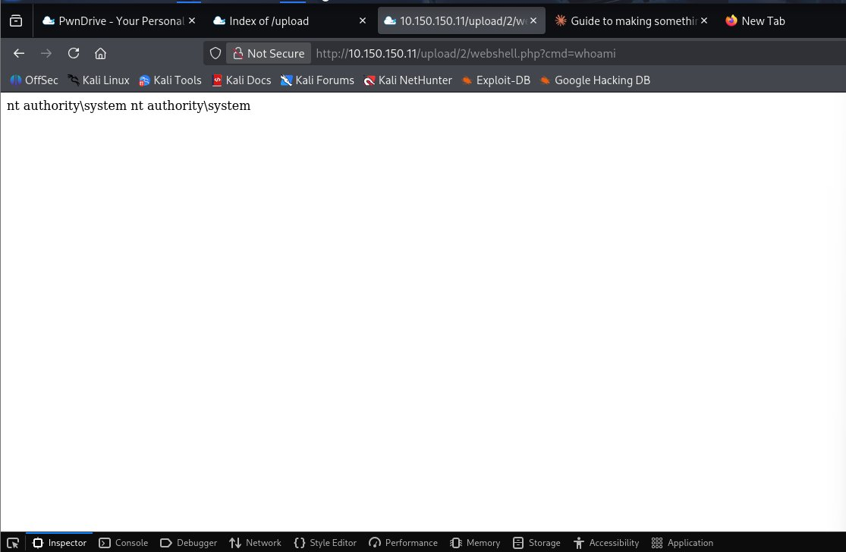
Figure 4 - RCE confirmed: running as NT AUTHORITY\SYSTEM (highest Windows privilege)

4. Post-Exploitation & Flag Retrieval
Objective: Enumerate the system and retrieve the flag.
Since the web server was already running as NT AUTHORITY\SYSTEM, no privilege escalation was required. The Administrator's Desktop was enumerated and FLAG1.txt was located and read directly via the webshell.
http://10.150.150.11/upload/2/webshell.php?cmd=type C:\Users\Administrator\Desktop\FLAG1.txt
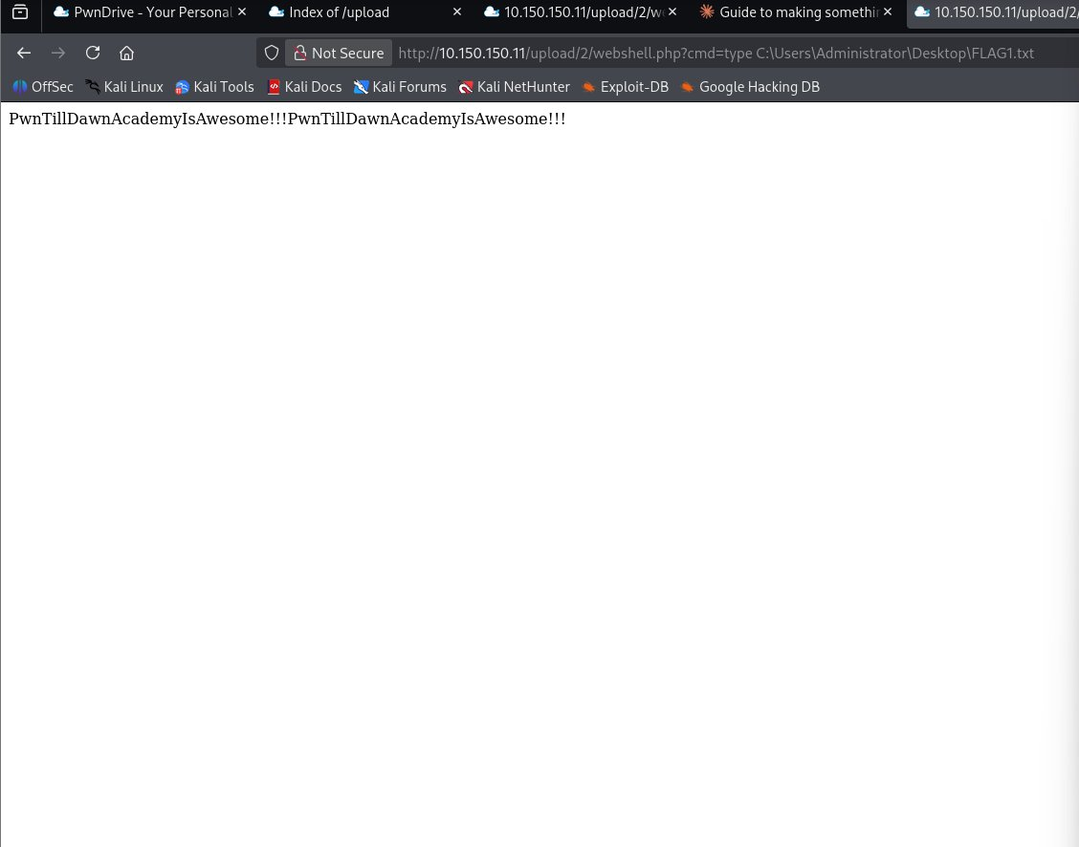
Figure 5 - FLAG1 successfully retrieved from C:\Users\Administrator\Desktop\FLAG1.txt
FLAG1: PwnTillDawnAcademyIsAwesome!!!

5. Recommendations
The following security improvements are recommended to remediate the identified vulnerabilities:
- Implement authentication on ALL admin panel pages - never expose user management without login
- Restrict file uploads to allowed file types only (whitelist .jpg, .png, .pdf etc.)
- Disable directory indexing on the Apache web server (Options -Indexes)
- Run the web server as a low-privilege user, not NT AUTHORITY\SYSTEM
- Implement a Web Application Firewall (WAF) to block malicious requests
- Regularly audit exposed endpoints and enforce access controls
- Conduct regular penetration testing to identify vulnerabilities proactively

